

**EXETER CITY AFC SUPPORTERS SOCIETY LIMITED**

**COMPANY REGISTRATION NUMBER: IP029339R**

**DRAFT MINUTES OF THE 2022 AGM**

# held on 12 November 2022 at the Phoenix Centre

**Trustees present:** Nick Hawker, Will Barrett, Julen Beer, Mark Cordell, Elaine Davis, Nick Edwards, Pete Ferlie, Doug Gillard, Clive Harrison, Richard Knight, Neil Le Milliere.

**Officers Present:** Phil Burden (Trust Secretary), Steve Chudley (Trust Finance Officer), John Street (Returning Officer), Pete Cordwell (Minutes Taker).

**Representing Exeter City AFC. Ltd.** Julian Tagg, Club President and Director of External Affairs

# Trust Members:

60 members attended the meeting.

# Apologies:

Dave Galt, Nick Bray, Steve Ridler, Paul Pettinger, David Philips, Anthony Crowther, Michael Clark, Malcom Frazer, Tom Farley, Phil Bater, Sue Price, Alistair Yates, Rob Doidge.

# Welcome

NH welcomed members to the Exeter City Supporters’ Trust Annual General Meeting. “We never thought promotion would happen the way it did,” he said.

# Approval of Previous AGM Minutes from 2021

There were no amendments or corrections required.

**Motion.** The 2022 AGM accepts the minutes of the 2021 AGM.

**Proposed by:** Phil Wright

**Seconded by:** Martin Weiler

The motion was carried with 1 abstention

# Matters arising:

There were no matters arising

# Approval of the Exeter City AFC Supporters Society Ltd Financial Statement

Steve Chudley spoke about the Trust Accounts, which can be found on the Trust Website. Income is up by £8,600 and expenditure down by £14,800. Membership is up by 300, of which 200 are Junior Grecians. Steve spoke about these two graphs.

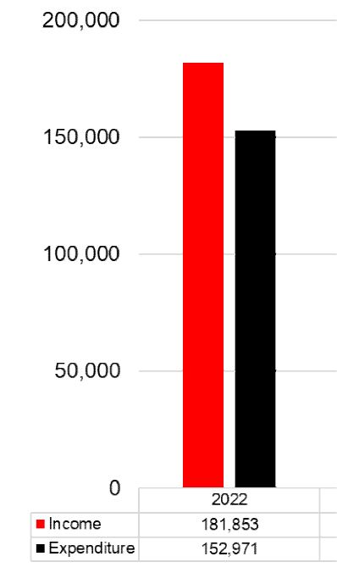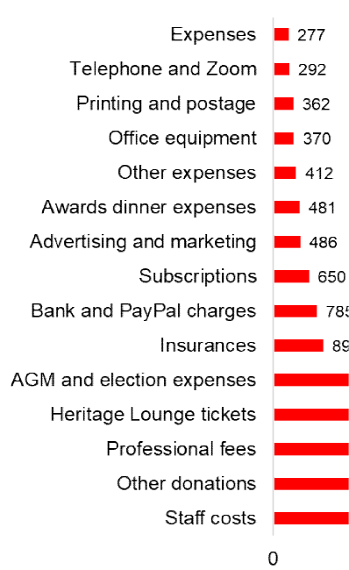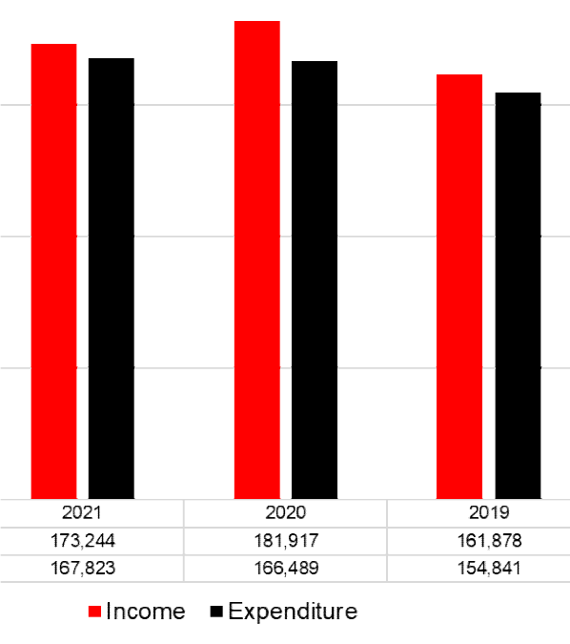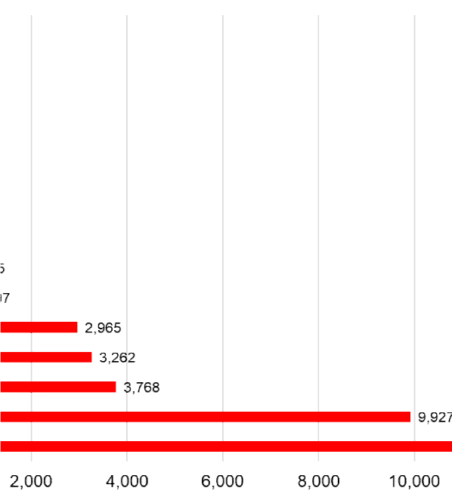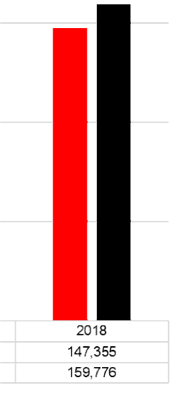

Steve thanked Simon Gould, accountant and Stephen Bright, our auditor There were no questions.

**Motion.** The membership approves acceptance of the Trust Accounts.

**Proposer**: Nigel Banks

**Seconder**: Paul Bray

# The motion was carried unanimously, with no abstentions.

1. **Reappointment of the Trust Auditor**

Steve Bright pointed out that some might consider his independence could be questioned by the fact that he had been Trust Auditor for 19 years. He was happy to continue.

**Proposal:** To re-appoint Stephen Bright as auditor for the Exeter City Supporters’ Trust

**Proposer**: Alan Anderson

**Seconder**: Paul Farley

# The motion was carried unanimously

The Chair thanked Steve Bright for all his help putting the accounts together.

# Chief Operating Officer Address. Justin Quick

* Justin outlined the Year End performance
* Net Current Assets are £3.4m (2021 £2.6m)
* Operating Loss is £269k (2021 £1.4m)
* Transfer Income has been £1.5m (2021 £4.9m)
* Profit for the Financial Year of £1m (2021 £2.9m)

*\*Note. 2021 included Covid-related reduced income*

He spoke about some of the post balance sheet events. The redevelopment of the Cliff Hill Training Ground (£3m total) which followed Supporters’ Trust membership vote in October 2021. Anticipated completion January 2023 when the existing pavilion building will be demolished

He clarified the position of our current leases

* OTR (Exeter) Limited – September 2032
* Exeter City Council – August 2046
* Clifford Hill Training Ground – September 2046

The club is grateful for the support of all three parties to allow the business to trade with these vital parts of our estate.

The outlook for 2022/23 looks good with increased gate and EFL / PL Funding following promotion; increased investment in playing budget in line with divisional status; sustainable League One club next is the next focus. And Alfie Pond transfer underpins importance of our Academy.

Energy prices will increase in summer 2023 at end of 3yr contracts. The Club are now paying the Real Living Wage. Efficiencies include: Bore holes at both sites, new finance system with automated processes.

Justin also spoke about the current football finance landscape.

The EFL continue to work on new distribution of fund model. Government work is linked to this via ‘White Paper’. A key focus is to avoid direct player wage inflation and to consider what article 48 does to our revenue streams. There is a continued risk around transfer revenue of any changes.

Thanks to Keith Mason for his work as Finance Director over the last seven years, a period of much positive change within the club.

Thanks to Haines Watts our Auditors and Ben De Cruz. Accounts will be finalised within the next month, with board and shareholder approval prior to the end of the calendar year. And filed in the new year once these aspects have been completed.

Questions for Justin.

Q. Are our net assets in the bank or capital? A. It is not that simple, although our net assets are available.

Q. What’s the impact of inflation and energy costs? A. We have three year contracts on utilities which don’t run out until next year. We pay the real living wage and its increase in April will be a real challenge. We are confident about this year but not so for the following year.

Q. Are we operating at a loss? A. We have a negative of 500k which we hope will be covered by transfer income.

Q. How much do we get from Sky? A.10k away game; 35k home game.

Q. Are we using the full capacity of the ground? Can we increase it? A. Seats are often sold out. Gaps are from people who have bought tickets and not attended. We are looking to encourage people to return season tickets for resale if they are unable to attend. There has been a 10% reduction in capacity over time (Green Guide). Segregation is different for each game.

# Club President Address. Julian Tagg

See Appendix 1 for the full address.

# Declaration of 2022 Trust Board Election Result

The Trust Returning Officer, John Street declared the result of the 2022 Trust Board Election.

**Will Barrett 744**

**Steven Chown 597**

**Clive Harrison 457**

**Richard Knight 649**

Ian Lowman 354

Matthew Moore 275

# Jamie Pelmear 501

Mick Sinclair 283

Paul West 319

Alistair Yates 334

Those highlighted in bold were elected.

The election turnout was 33%. 1,110 voted electronically and 31 by paper ballot.

# Presentation by Nick Hawker, Chair, Exeter City Supporters’ Trust

Trustees can serve for only nine consecutive years which means that this year we are losing two real stalwarts of the Trust.

Neil Le Milliere has been my “go to person” if I have a problem. I have always asked him, “What do you think, Neil?” He’ll be a great loss.

Elaine Davis has made a massive contribution to the Trust and the Club. She has had a huge impact. I don’t know how we’ll manage without her.

Presentations were made.

Elaine thanked everyone for their support, saying “I couldn’t do any of it without you.” She said the response to *Kit out the Cliff* had been amazing.

# Trust Board Resolution 1

The TB proposes that the existing £100k cash donation to the Club, paid in monthly instalments, is converted to a loan. This would be subject to the Club not being disadvantaged in respect of the EFL Salary Cost Management Protocol (SCMP), and negatively impacting the playing budget. The purpose for making this change is to allow the Trust to receive repayment of the loan by way of shares, thus growing our % holding in line with the strategic aim of reaching a 75% +1 shareholding.

# Supporting Information

To achieve this, and to ensure we do not compromise our current shareholding we would need to make a change to the club’s Articles to allow for the issue of shares in such a manner. We have sought legal advice that has delivered the following additions to the Articles in the appropriate section:

1. a) An ordinary resolution is passed each year at the point when the Club knows how many shares the Trust will receive, and therefore how many shares would be

offered to the minority shareholders. The benefit of this is that the authority provided to the directors for allotting shares can be precisely ascertained. However, this would require an ordinary resolution to be passed each year, which would have an administrative burden.

1. b) Alternatively, the Articles could be amended to provide directors the authority to allot shares for the next five years (the Companies Act prevents authority being grantedfor a period longer than five years). The benefit of this is that the authority would not need to be provided each year, and would only need renewing once the five-year period was up. However, the number of shares which the directors are authorised to allot would have to be carefully considered, as this would need to include the shares allotted to the Trust over the next five years, and any shares allotted to the Minority Shareholders during the same period. The number of shares to be allotted over that five-year period would be based on some unknown factors at the time the authority was put in place, such as the value of each share at the time of allotment, and the level of investment from the Trust and Minority Shareholders.
2. c) Pre-Emption Rights – Currently, any allotment of shares by the Club would trigger the statutory pre-emption rights in the Companies Act. Therefore, without any amendments to the Articles when the Club intended to allot £100,000 of shares to the Trust each year, the Club would first have to offer them to all shareholders (both the Trust and the Minority). These statutory pre-emption rights therefore need to be amended. The Articles can include a provision that these pre-emption rights do not apply in relation to the Trust Allotment. This would allow the Club to allot £100,000 of shares to the Trust, without having to offer any of these shares to the Minority Shareholder.
3. d) Anti-Dilution – The Articles can also include provisions that following a Trust Allotment, the Minority Shareholders are to be offered such number of shares as would allow them to maintain the percentage shareholding which they had before the Trust Allotment. The shares would be offered at the same price per share which the Trust paid for its shares. We need to be mindful that this is different to the traditional pre-emption procedure referred to above and there could be a scenario, however unlikely, where all Minority Shareholders wish to exercise their anti-dilution rights which would ultimately mean that the Trust would not increase its percentage shareholding of the Club notwithstanding the additional investment it has made. The end result here would be analogous to a traditional right issue where all shareholders invest additional funds but do not increase their respective percentage shareholdings in the Club.
4. e) Fractional Shares – For Minority Shareholders who have very small shareholdings (for example some only hold 1 ordinary share), the number of shares required to maintain their current percentage shareholding would be less than one. As it’s not possible to allot fractions of shares, the two options would be:
   1. the Minority Shareholder receives one full share, which would actually result in their percentage shareholding increasing rather than staying the same; or
   2. the Minority Shareholder is not entitled to receive a share, which would result in their shareholding being diluted, even if they were willing to invest to maintain that percentage.
5. f) To alleviate this problem, one option is to subdivide the Club’s share capital. This would mean splitting each £1 share into, for example, 100 shares of £0.01 each. This would result in each shareholder holding 100 times more shares than they would have now, but as every shareholder would go up by the same factor of 100, this wouldn’t affect the overall percentages of shares each shareholder held.

The benefit would be that where a Minority Shareholder currently holds one share and following a Trust allotment, they would require 0.2 shares to maintain their current shareholding, the situation following a sub-division of shares would be that they would hold 100 shares and would require 20 shares to maintain that percentage. Having a smaller

nominal value, but a higher number of shares, therefore provides greater flexibility for precisely allotting shares to Minority Shareholders.

g) Valuing the Shares – There will need to be an objective mechanism for valuing how much the Trust should pay per share for any given Trust Allotment. We are not able to provide financial, tax or accounting advice and therefore the Club should seek independent advice for determining what the best method for valuing the shares is. However, as an indication of possible mechanism, one method would be having the Club’s accountants value the Club in advance of each Trust Allotment, but this would incur accountancy fees each year.

To avoid the need for such a valuation each year, another method could be basing the share price on the Club’s net asset value in the statutory accounts filed most recently before the Trust Allotment. The share price could be the net asset value divided by the number of shares. This could be a simple method of calculating the share price (but of course the Club should seek independent financial advice before deciding on any such method).

Whatever method is to be adopted; this can be reflected in the Articles so there is certainty at the time of each Trust Allotment what price is to be paid.

# Questions regarding the proposal

Q. Under SCMP (Salary Cap Management Protocol), what percentage can we spend on players? NH promised, after checking, to supply that information to the questioner (JK)

Q. How long will it take to reach 75% shares +1? A. It depends on the price of shares which may fluctuate.

Q. How many shares will 100k buy? A. We haven’t done it this year so we don’t know.

Q. Can this be undone? A. We can always choose to reverse the proposal if things become difficult.

# The proposal was passed with 4 abstentions. There were 5 proxy votes in favour.

**Trust Chair Address**

See Appendix 1 for the full address.

Q. What did we offer the new manager to get him to City? A. Enough to get him. More than Matt Taylor.

Q. What’s happening with appraisals? A. NH. Mine is being done in December.

Q. Are we going to recognise the person who enabled the CHTG? A. Not sure. We think rooms will be named after certain people.

Q. What is happening about priority ticketing problems. A. Spektrix has fallen short. The new system should improve things. You will look after your own accounts.

Q. What is the relationship with the Women’s Club? A. The Trust’s influence is strong. They are with ECCT. CH and JT are heavily involved. The Trust has increased its contribution from 5k to 25k. 110 girls are attending the Women’s Development Centre. Funding has been awarded for centres in North Devon.

Q. What are the Trusts’ cash reserves? A. £930,000 in bank. £8,333 a month goes to the Club. The money set aside for Kit out the Cliff stands at £50,000.

Q. What is the progress on the John Lewis Trust Suite? Work is finished on this CAPEX project. Work is now needed in the downstairs bar.

Q. CAMRA who, for years have held their beer festival at the Club, were advised they couldn’t hold it there this year because of building work. They had moved it to the Corn Exchange. Could they hold it at the Club next year? NH promised to investigate and get back to the questioner. (PP)

# Any Other Business

Fans’ Forum with Gary Caldwell and David Perkins is on the 22nd November.

Next year is the Trust’s 20th anniversary. There will be a Dick Pym exhibition in Topsham from March to October 2023. Richard Pym described some of the memorabilia there, including the ball from Brazil and a mannekin with Bolton kit.

End of Meeting.

Appendix 1 –Julian Tagg President, Director of Football and External Affairs TRUST AGM 12/11/22

Seven years in the Academy, 20 years in the boardroom - 27 years of service. As is often said you get less for murder. Looking back, perhaps we should have taken that alternative approach with our previous owners, by now I would be out on parole.

We all know that our dedication to our club drives us all to take on the ridiculous, bordering on the impossible, something I’m proud to say we continue to do at Exeter City Football Club on a daily basis. That’s probably a good place to start this report.

**FOOTBALL FIRST**

What a great year. On this day, at this time last year we were about to take on Oldham Athletic. We won the match 2-1 - what we didn’t know was that we were “all aboard” for a season-long emotional rollercoaster, and we were headed toward that great promotion day at SJP but also our own moment in time, in the City's high street, celebrating a long awaited promotion.

Under Matt Taylor’s guidance we had four years of toil and pandemic and way too many Wembley nightmares until finally it all came together. The players, the bootroom, the manager, Club and Trust boards and the fans all played their part in that success. It is indeed what dreams are made of.

Unfortunately, the football world does not stand still. There are few, if any, in this room that didn’t know that MT was going to leave us at some point. What nobody knew, was when. Salford and Charlton came and went, they failed but Rotherham, as we now know, did not. We also didn’t know that he was going to take four possibly five bootroom staff to the frozen North.

It's tough to take. There are too many, perhaps I should correct myself, so many examples of players, managers, backroom staff, and boot room staff that we have developed, progressed and helped them to move on to greater things. I can only describe the feeling, when anybody moves on, be it youth player, player or staff, as gut wrenchingly disappointing. However, on the other hand, it's something we do, something we do very, very, well. We have to be magnanimous and it's something of which we should be very proud.

This time last year somebody said at this meeting and I quote ….. “like it or not…who is going to leave us for more lucrative climes, who will we further train so they may take the next career steps, internal or external, who might take their place or indeed is there anybody?” Prophetic? By now it should be obvious. The song by Chumbawamba springs to mind…. Anybody know it ? Some blank faces… “I get knocked down’…if ever there is an anthem we should adopt, it’s this song!

Today, a bootroom that was built over seven long years and achieved the success we are now enjoying is all but cleaned out. It cannot be put back, like for like, instantly, we all know that. However, there are still two if not three "of our own" that have stepped up in style and will be complimented by others to take this club to the next steps of its ambition.

We, as we must, move on. Gary Caldwell is an excellent acquisition emanating from a sound process that, I believe, will be very successful appointment. He and Kevin Nicholson, promoted from within, are both focussed individuals who are determined to succeed. Marcus Flitcroft takes on more responsibility and is doing a fantastic job in analytics and recruitment, whilst Jonathan Grounds is progressing well on his new coaching journey and surprise of all surprises, Nicky Ajose has, again I quote “been a driving force and a coaching revelation”. Driving force and revelation are perhaps not

words I would have chosen to describe Nicky's ECFC playing career, but he is proving to me a considerable asset now.

The addition of David Perkins as our new u23s coach, is a relatively raw but massively determined and enthusiastic individual. It’s not complete but the bootroom recovery is well underway.

**THE ACADEMY**

I'll try to keep it short! And in order to do so, I can't do better than to review here what some of you may have seen on our excellent social media offering, thanks to Scott and Craig and team, especially as this week is the EFL Youth Week. The stats speak for themselves.

* Eight scholars have made First Team debuts already this season, the most ever in one season at ECFC
* During the promotion season of 2021/22, ECFC averaged 4.17 Academy graduates in the starting 11 (EFL average was 1.25)
* So far in 2022/23, the Club’s first season back in League One, ECFC are averaging

5.41 Academy graduates in the starting 11. The average is 1.89

* The starting line-up has included seven Academy graduates in League One fixtures on two occasions this season, home wins against Wycombe 3-1 and Fleetwood 2-1
* 394 First Team games in a row with an Academy graduate making an appearance (over seven years!)
* Sonny Cox is the only U18 player to score in League One so far this season
* Dean Moxey, my very first Academy signing, is the Academy graduate with the most professional career appearances, currently on 624 and playing in the National League for Torquay United
* Liam Sercombe is currently on 595 career professional appearances, still playing in League One with Cheltenham Town
* There are currently five Academy graduates on professional contracts at Premier League Clubs: Ollie Watkins, Ethan Ampadu, Jay Stansfield, Ben Chrisene and Alfie Pond
* Two players are excelling in the Championship this season, Jordan Storey who has already made 20 appearances and scored two goals in a team that has kept 11 clean sheets. Matt Grimes continues to captain Swansea City and is a key player in their promotion chasing team.

So firstly respect, even homage, to Arran Pugh and Kevin Nicholson in particular, but also to all the Academy staff who have had a torrid time during covid, suffered massive staff shortages but still, somehow, came out stronger and even more determined. With an Academy Technical Board that meets throughout the year ensuring that quarterly reports go to the Club board, three separate external audits and a serious reputation to uphold, the Academy is in good hands.

It’s not my remit here, but allow me to make brief mention and to thank another part of the ECFC family the Exeter City Community Trust. Jamie and his crew are loyal and committed to our football family and the work they have done and continue to do for our local community on behalf of our club ensures the reputation of Exeter City FC is held in high regard across the whole of Greater Exeter.

**Finally the new CHTG facilities.**

The draw against Man United, the draw against Liverpool, getting promotion, four times, in my time and yours, were all significant unbelievable and iconic moments. However for me it’s the greatest feeling and greatest sense of satisfaction, certainly during my tenure, to see

a superb new building literally appear in front of the dilapidated existing, much loved but well past its 1974, sell by date out at the Cliff Hill Training Ground. The plans may have changed over time somewhat but the date on the first the email in my, "Cat and Fiddle" file, between Mike Phillips Chris Jay and myself says, October 2014. That tells me that we, at ECFC always get there in the end. That song again springs to mind! I can’t wait to see your faces, especially if Elaine has anything to do with it, when you all, which you will, get to see it.

I would like to think that the club in better condition than when we found it. Minus £4.8m to plus £4.8m credit. (Bit of poetic licence as Justin has left the room!). There’s a new, well two really, new stands, the Stagecoach Adam Stansfield Stand and an away end that surely should have been named “The Dodgy Barnet Stand”, fantastic new facilities at Cliff Hill Training Ground and we have gone from Conference League to League One and from” no Academy” to, the stats say, the best Cat 3 Academy in the country.

I commend this report to the AGM and thank you all, from the heart, for the magnificent effort and unrelenting dedication you and all the people I have worked with, show toward the cause that is the ECFC family.

Julian Tagg

President, Director of Football and External Affairs.

Appendix 2 – Nick Hawker Trust Chairman Thank you all for coming.

I’m going to provide you with an overview of the last year but also include some information on, not just what the Trust has done, or caused to be done, but how we’ve gone about doing it.

So, a little bit of background…

During my tenure as Chair of the Trust my over-riding objective has been to continuously improve the interaction between Club and Trust. I still recall my first Club Board meeting with some trepidation, such was the contentiousness between the two organisations. I’m relieved to say that latterly these meetings have been collaborative, progressive, and increasingly, ambitious. I’m not at all sure it’s always evident, but we have made considerable progress.

Over the years I’m extremely grateful to David Lee, with whom I first developed our current Club/Trust pathway, through good governance, to a more mutually respectful relationship. It was David who first actively recognised the right of the majority shareholder to have a real say in how the business that we owned, behaved. Following on from David, Richard Pym continued to build on that pathway, helping us to attract skilled directors who, remarkably, are willing to provide their services for free but more importantly, do so because we are supporter owned. During his own tenure Richard arranged for the repayment of the loan outstanding by the club to the Trust. Over £800k. That is very relevant to where we are today, as will become apparent!

It was Jonathan Hart, one of our independent Directors, who noted ‘we should aspire to be the pre-eminent supporter owned club in the country’. Today, we have a club board that are fully engaged, and I believe, aligned to the ambitions of us all, as a supporter owned club.

Amid all of this, we are here today because of several reasons… I’ve spoken before of the gratitude we should all show the first pioneers of supporter ownership at Exeter City, and the many supporters who have represented our interests as Trustees and officers over the years. The past two seasons we have sponsored our home games against Northampton Town to acknowledge the motivation provided to those pioneers by the late Brian Lomax, then Chair of Northampton Town. Some of those pioneers are here today, I’m sure and I hope, in the coming 12 months, our 20th Anniversary of ownership, we will acknowledge all of this.

We are all cognisant, of course, of the amazing contribution the Academy make to our fortunes. Arran Pugh and his team are not exactly ‘un-noticed heroes of the Club’, but nor do we hear their names chanted on the Big Bank and to be frank, they should be.

And the one constant throughout all of those years, has been the Trust of course, but also Julian Tagg. It’s impossible to fully understand the contribution and value that Julian has been and is to the club. We still meet on a weekly basis, normally around 10 o’clock on Thursdays at Lloyds Lounge, if you ever want to join us, and Julian still pays for the coffee and toasted tea cake… a fact I’m properly proud of! Sometimes, I’m not at all sure what we decide at these meetings, I only know that on the rare occasions we don’t have them, I notice it. I think they are an integral part of the relationship between Trust and Club.

So today, we are where we are. Let me try and explain where that is.

If you haven’t already read the Club Trust Agreement, then please do. It’s on the Trust web site and it’s essential reading for all Trustees!!! I’m certain the newly elected Trustees are all ‘word perfect’ on it!

This is a simple diagram of the decision-making process between Club and Trust.

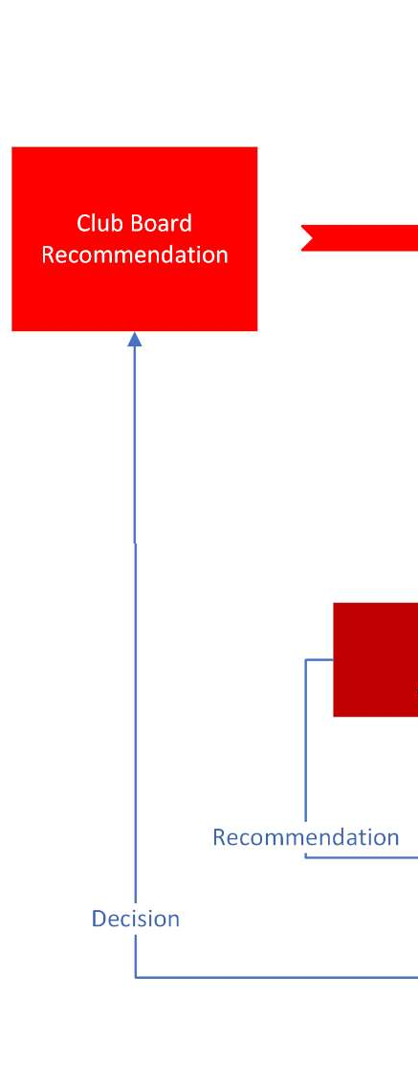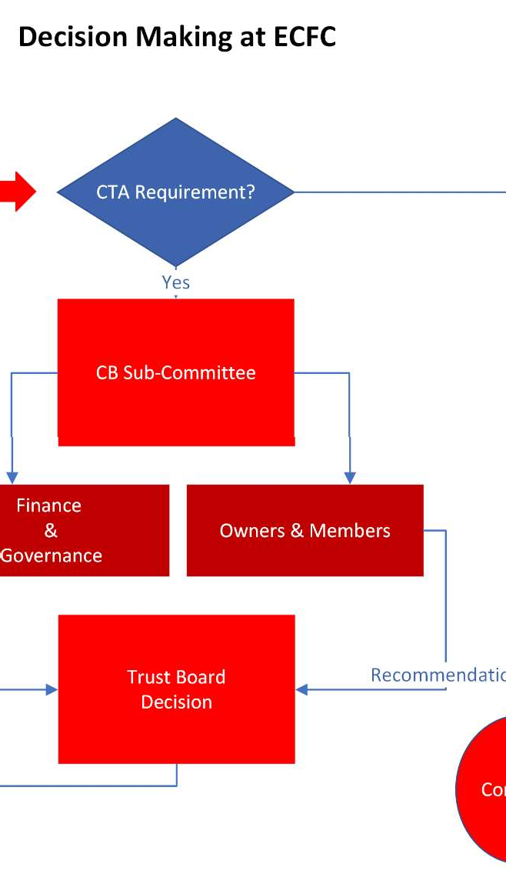

Any Club Board decision needs to be checked against the conditions of the CTA. If there is no requirement, then the decision is made by the Club Board. Where there is a requirement, the matter is referred to one of two Club Board sub-committees:

The Finance & Governance Group; or The Supporter Experience Group.

Each of these are chaired by a Trust or Officer of the Trust. Currently these are Steve Chudley (FGG) and Clive Harrison (Supporter Experience). Their role is to make a recommendation to the Trust Board, via a working group (which involves members as well as Trustees), around the benefit or otherwise of the decision required.

Two recent decisions have been the investment in the Cliff Hill Training ground accommodation, and the employment of Gary Caldwell. Both were covered by the CTA in so much that each involved a contract to a value in excess of £50k. In the event, the Cliff Hill investment was felt too important for the Trust Board alone to decide, and so it was deferred to you, the members.

You may recall a meeting, held here, around the CHTG investment, and I believe that recently, for the first time, Trustees were involved in the interview process for the new manager. Nick Edwards, Julen Beer, and Peter Ferlie all attended a second interview. Clive Harrison and Elaine Davis, both Trustee elected Club Board directors also attended an interview each.

At every level of club governance, the Trust are involved.

For the past 2 years, and I suspect into the future, the Trust have supported the playing budget to the tune of at least £200,000. Two years ago, Matt Taylor requested a playing budget of £1.750m. The Trust offered an additional £500k to cover the following three years, to be spent as Matt required. I still recall the meeting we told Matt of our offer, who commented, ‘you’ve sent my head in a spin’. This is the difference you have made. During the promotion season the playing budget was supplemented by you… directly!

This arrangement has been hugely beneficial. Not only did it help us to gain promotion through an enhanced playing budget but, I’m delighted to say, we have not parted with a penny! Through good fiscal governance, throughout this period, we have maintained an agreed strategic reserve, equivalent to 2-3 months’ salary, which has meant the club has always afforded the playing budget!

Today, as I’m sure you are aware, the Trust, you, have guaranteed a £600k loan facility in respect of the Cliff Hill.

Some of you may recall, at last year’s meeting, Richard Pym commenting on the poor morale of the club back-office staff. Since then, I am delighted to inform you that each member of staff received an end of season ‘Promotion’ bonus, the back-office has been refurbished with new furniture, pay scales have been reviewed and recently enhanced to reflect the challenging economy, and we have introduced sick-pay benefit, cash back on medical expenses, and a salary protection scheme for long term illness. We have also introduced a bonus scheme that potentially will benefit every employee, subject to business performance.

You may also recall that at last year’s meeting a member required the club to become a ‘real living wage’ payer. I’m delighted to say that this has been enacted. The Club, through Trust intervention, are now a competitive employer.

To continue, let me tell you about the Club Board sub-committees, chaired by Trustees.

The Finance & Governance group, chaired by Steve Chudley, the Trusts Finance Officer, review the club’s management accounts on a monthly basis and other financial statements such as budgets, cash flows, and periodic statements, making appropriate recommendations to the Trust Board in respect of actions required.

The Supporter Experience Sub-Committee, chaired by Trustee Clive Harrison, are responsible for the experience you have at games. Most recently, Clive has led the group in combatting the unfortunate chanting that has occurred from time to time which appears, for the moment, to have worked. This has a real impact on the club as I know some supporters felt so strongly that they chose to no longer attend games which of course, loses us revenue.

At a recent Fans’ Forum I was asked what tangible benefit the independent Directors delivered. I must admit I was taken aback by, in fact, a very reasonable question. During the year, amongst many other things, I have recorded the following;

Clive Bawden has helped to design and deploy the transition of accounting systems from SAGE to XERO. This will provide speedier and more accurate accounting information, but also efficiencies in the recording and paying of expenses and approvals. Clive has also worked on our risk register that will soon become an integral part of the Club/Trust Board decision making considerations. I’m also reliably informed that without his fan input, the club shop would be significantly less profitable, such are his purchases of merchandise!

Jonathan Hart sits on the Supporter Experience sub-committee and is currently helping to design a marketing campaign to improve the recruitment of Trust members. To my knowledge, this is the first time ever the club has acted on our behalf to develop membership, using its resource and skills. This is a major step forward. Jonathan also sits on the Academy Technical Board.

Finally, Jeremy Tipper has helped to deliver a comprehensive HR software solution that will enable us to administer and deploy club policies and people related comms. Jeremy was also instrumental in creating the framework within which we recruited our new manager and is providing further HR input shortly. Jeremy was last heard from whilst at the summit of Mount Kilimanjaro…. I have a video. He, together with his partner and mountain guides were singing the Stanno Song.

The point of my raising these things – the club shop merchandise, the membership recruitment drive, and the singing of the ‘Stanno’ song, it’s a demonstration of not only their commitment to the club, but alsoto our model of ownership. They have, I believe, bought into Exeter City, just as we have.

All three Directors, like you, travel the distances to represent the club all over the country, and here in Exeter. No expenses paid for this!

Toward the end of last season, we became aware of difficulties with the Priority ticketing arrangements. We had hoped to transition our membership administration to SPEKTRIX, the Club’s ticketing solution but sadly, it has fallen well short of our expectations. To this end the Trust have invested in new membership software that will resolve these problems and deliver a more complete service to our members. The new solution brings together the various functions we use under one umbrella and as members, you will each have a login to access member information. Following go-live the numerous pieces of software we use will be brought under one solution that will offer membership polls, including election ballots, blogs, event booking, and an automated e-mailing system. My hope, in the new year, is that we will be able to add yourselves to the decision-making diagram in so much that, by offering polls out to you, your preferences on certain matters can be recorded and acted on. I should record my thanks to St Mirren Football Club for allowing us access to their system and for the advice and guidance they provided – they use the same system!

Finally, since December last year, we have been working with a gentleman from Northumbria University to produce a ‘Supporter Year End Report’, that will contain all of the club’s year end data together with explanations, graphs, photographs and statistics that bring the data to life. We lost around 4 weeks whilst our attention turned to recruiting a new manager, but my hope is that it will be available by December 8th – the date of the Club AGM. We’ll e-mail this out to you once complete but shortly afterwards will seek to form a forum to review its content and design, to improve the offering for a mid-season re-budget effort.

Finally, I’m delighted that our partnership with both CCT and ECI continues to deliver benefit to the community. Even independently, we make a difference, and it was my great honour to join with fellow Trustee Doug Gillard, and our opposite numbers from Torquay United and Plymouth Argyle to celebrate the recognition of Argyle striker Jack Leslie, who has a statue outside Home Park, and was posthumously awarded an England cap following his omission from an England squad on the basis of his skin colour! We have moved on.

Finally, may I thank my fellow Trustees and Club Board directors for their support over the past twelve months, and for the great enthusiasm and work ethic that we all benefit from.

I’m very happy to answer any questions people have.